**Step-by-Step Guide to Deploying a Spring Boot App on Minikube using Kubernetes**

**NAME : SRI SURIYA S**

**ROLL NO : 22CSL265**

# Step 1: Create a New Directory

This command creates a new directory named task4 in the current working directory. **Code:**

mkdir task4

# Step 2: Navigate to the Directory

This command moves you into the task4 directory.

**Code:**

cd task4

# Step 3: Create a YAML Configuration File

This command opens the **sample.yaml** file in the Vim text editor.

If the file does not exist, Vim will create it.

Inside Vim:

* Press **i** to enter insert mode.

* Write your Kubernetes YAML configuration (e.g., a deployment or service).

* Press **ESC**, type **:wq**, and press **Enter** to save and exit.

**Code:**

vim sample.yaml

**Screenshot:**

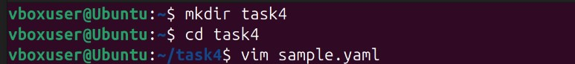

# Step 4: Apply the YAML Configuration Using kubectl

This command deploys resources defined in sample.yaml to the Kubernetes cluster.

Ensure that **Minikube** or another Kubernetes cluster is running before executing this.

**Code:**

kubectl apply -f sample.yaml

**Screenshot:**



# Step 5: Check Running Pods

This command lists all running pods in the Kubernetes cluster.

It provides details such as pod name, status, restarts, and age.

**Code:**

kubectl get pods

**Screenshot:**



# Step 6: Expose the Spring Boot Application via Minikube

This command exposes the springboot-app service in Minikube.

It opens the application in a web browser by forwarding traffic to a local machine-accessible URL.

**Code:**

minikube service springboot-app

**Screenshot:**

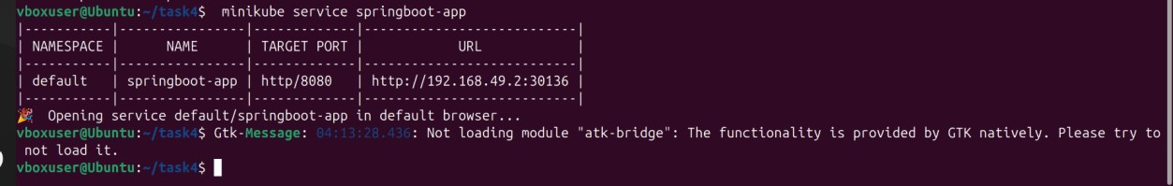

**Prerequisites:**

**1)Minikube installed and running**

**Code:**

minikube start

**2)kubectl installed and configured**

**Code:**

kubectl version --client

**3)A valid sample.yaml file containing Kubernetes resource definitions (e.g., Deployment, Service).**

